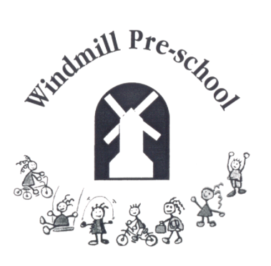
Windmill Pre-school
Brill C of E Combined School
The Firs, Brill, Bucks
HP18 9RY

01844 238859

email: wps@windmillpre.plus.com

Manager : Claire Baker

January 2020

Dear Parent/Carer

What has your child done well at home and out of Pre-School?

As part of our philosophy to provide an outstanding partnership with everyone who comes to Pre-School, we would like to introduce you to our Children’s Achievement Board.

Attached to this letter is a “cloud” shape on which you can record an achievement or milestone that your child reaches at home during the next half term. These can be “big” events, such as sleeping all night in their bed, or smaller incidents such as being kind to a sibling. A photograph, if applicable, would be lovely, but we really want this to be an informal snapshot which could be a few lines to celebrate achievements.

We hope that you will cut the cloud out and attach it to our Achievement Board which is situated to the right of the kitchen and share with us your child’s accomplishments.

With best regards

Staff Team

Registered Charity No: 276395

Please cut out and attach to the Children’s Achievement Board

