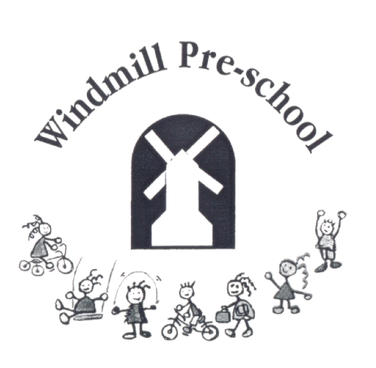
Windmill Pre-school
Brill C of E Combined School
The Firs, Brill, Bucks
HP18 9RY

01844 238859

Manager: Claire Baker

GRIEVANCE PROCEDURE

It is the policy of Windmill Pre-School to ensure that any employee with a grievance has access to a procedure which can lead to a speedy resolution of the grievance in a fair manner.

Stage 1

If you have a grievance about your employment, you should first raise it verbally with the Manager who should give you a reply within two working days.

Stage 2

If appropriate and only with the agreement of both parties, the grievance may be discussed with all the staff to help reach a satisfactory conclusion.

Stage 3

If the reply given at stage 1 (or if applicable stage 2) does not satisfactorily resolve the grievance, you should detail the grievance in writing to the Chair. The written grievance will then be responded to within five working days. The decision will be final.

Windmill Pre-school
Brill C of E Combined School
The Firs, Brill, Bucks
HP18 9RY

01844 238859

Manager: Claire Baker

DISCIPLINARY PROCEDURE

Purpose and Scope
It is the aim of Windmill Pre-School to encourage improvement in individual conduct. This procedure sets out the action that will be taken when conduct is in breach of the contract.

Principles
The procedure is designed to establish facts quickly and to deal consistently with disciplinary issues. No disciplinary action will be taken until a matter has been fully investigated.

At every stage you will have the opportunity to state your case and be represented, if you wish, by a fellow employee or professional advisor.

You have the right to appeal against any disciplinary penalty.

The Procedure
Stage 1 Verbal warning.
If your conduct or performance is unsatisfactory you will be given a VERBAL WARNING which will be recorded. This warning will be disregarded after three months satisfactory service.

Stage 2 Written warning.
If the offence is serious, if there is no improvement in standards, or if a further offence occurs, you will be given a WRITTEN WARNING which will include the reason for the warning and a note that, if there is no improvement after one month, a final warning will be given.

Stage 3 Final written warning.
If your conduct or performance is still unsatisfactory, a FINAL WARNING will be given making it clear that any recurrence of the offence or other serious misconduct within a period of one month will result in dismissal.
Stage 4 Dismissal.
If there is no satisfactory improvement or if further serious misconduct occurs, you will be DISMISSED.

Gross Misconduct
If, after investigation it is confirmed that you have committed one of the following offences (the list is not exhaustive), you will normally be dismissed:
Harm or neglect of children
Theft
Damage through negligence to the property belonging to or used by the Pre-School
Fraud

While alleged gross misconduct is being investigated, you may be suspended, during which time the normal hourly rate will be paid. Any decision to dismiss will be taken by the Manager and Management Committee, only after a full investigation.

Appeals
If you wish to appeal against any disciplinary decision, you must do so within two working days. Your employer will hear the appeal and decide the case as impartially as possible.

During Covid 19 any meetings may need to take place virtually rather than face to face.

This policy was reviewed on 3rd April 2022

Bryony Smith – Chair of Windmill Pre-School Management Committee

…………………………………………………..

Claire Baker - Manager of Windmill Pre-School

……………………………………………………..

Registered Charity Number 276395

